LINKEDIN JOB TREND ANALYSIS USING PYTHON AND POWER BI
1. Introduction
The rapid growth of online job portals has made it easier for organizations to recruit employees and for job seekers to search for career opportunities. Among these platforms, LinkedIn is one of the most widely used professional networking websites, offering millions of job postings across different industries and locations.
Due to the large volume of available job postings, it is difficult for users to manually analyze hiring trends, salary patterns, preferred locations, and employment types. Data analytics provides an effective solution by transforming raw job data into meaningful insights.
This project analyzes LinkedIn job posting data using Python for data preprocessing and Power BI for visualization. The interactive dashboard helps users understand hiring trends, company recruitment patterns, work types, experience requirements, salary distribution, and geographical distribution of jobs.

2. Problem Statement
Job seekers often spend considerable time searching through thousands of job postings to understand hiring trends and identify suitable opportunities. Manual analysis of job market data is inefficient and time-consuming.
The objective of this project is to analyze LinkedIn job postings and visualize important recruitment trends such as hiring companies, job titles, locations, work types, experience levels, and salary distribution through an interactive Power BI dashboard.

3. Objectives
The objectives of this project are:
- To collect LinkedIn job posting data.
- To clean and preprocess the collected dataset.
- To analyze hiring trends across companies.
- To identify the most common job titles.
- To study work type distribution.
- To analyze experience level requirements.
- To study salary distribution.
- To visualize job locations using maps.
- To build an interactive Power BI dashboard.

4. Dataset Description
The dataset contains LinkedIn job posting information collected from online sources.
The dataset includes:
- Job ID
- Company Name
- Job Title
- Job Location
- Work Type
- Experience Level
- Salary
- Company Details
Dataset Summary:
- Total Job Postings: 1.814 Million
- Total Companies: 1.237 Million
- Average Salary: 88.40K
The dataset was imported into Python for preprocessing and later visualized in Power BI.

5. Data Cleaning
Before analysis, the dataset was cleaned to improve data quality.
The following preprocessing steps were performed:
- Removed duplicate records.
- Checked and handled missing values.
- Removed unwanted columns.
- Standardized column names.
- Converted salary values into a common numerical format.
- Verified data types.
- Prepared the cleaned dataset for visualization.
These steps improved the accuracy and reliability of the analysis.

6. Exploratory Data Analysis
Exploratory Data Analysis (EDA) was performed to identify important hiring trends.
The following analyses were conducted:
- Top Hiring Companies
- Top Job Titles
- Top Job Locations
- Work Type Distribution
- Experience Level Distribution
- Salary Distribution
- Geographic Distribution of Jobs
These analyses helped understand employment trends and recruitment patterns.

7. Skill Analysis
The original project objective included analyzing skill demand trends. However, the dataset used for this project did not contain a separate column listing the required skills for each job posting.
Therefore, detailed skill analysis and the Skill vs Role Matrix could not be generated. Future work can use datasets containing skill information or apply Natural Language Processing (NLP) to extract skills from job descriptions.

8. Dashboard Screenshots
Dashboard Components:
- Total Jobs
- Total Companies
- Average Salary
- Top Hiring Companies
- Top Job Titles
- Top Job Locations
- Work Type Distribution
- Experience Level
- Salary Distribution
- USA Job Location Map
- Interactive Filters
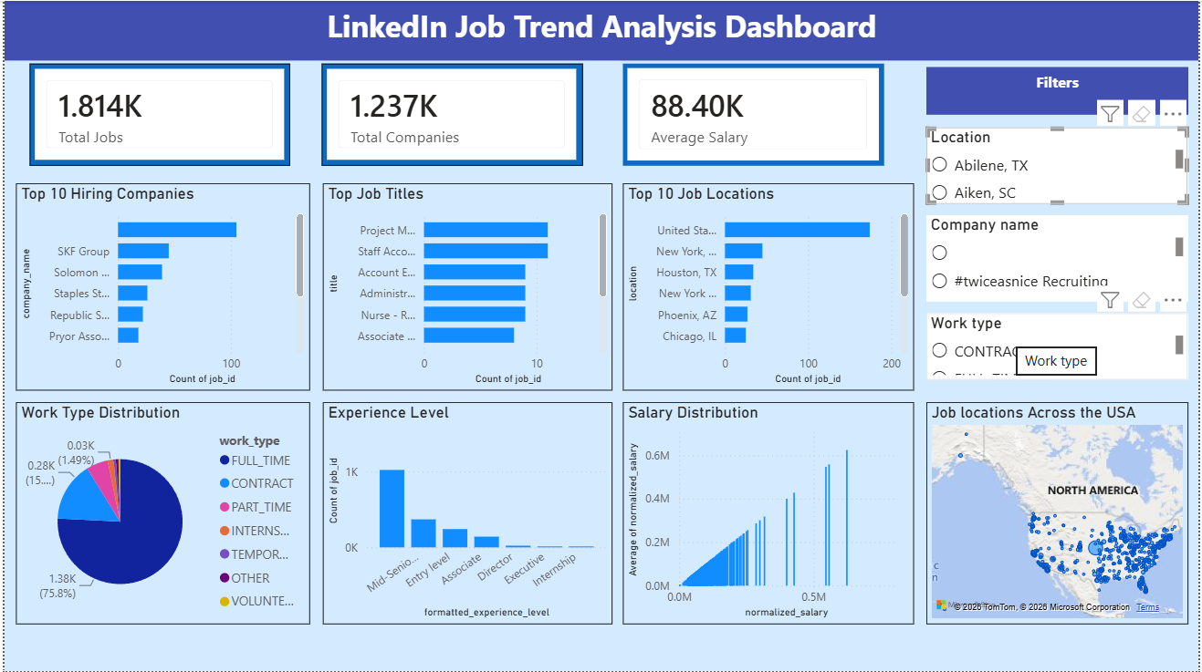

9. Key Insights
From the dashboard, the following insights were obtained:
- The dataset contains approximately 1.814 million job postings.
- More than 1.2 million companies have posted jobs.
- The average salary across the dataset is approximately 88.40K.
- Full-time jobs account for the largest proportion of job postings.
- Mid-Senior level positions dominate the recruitment market.
- Major cities such as New York, Houston, Phoenix, and Chicago have significant hiring activity.
- Salary distribution shows considerable variation among different positions.
- The map visualization indicates that employment opportunities are distributed across the United States.

10. Recommendations
Based on the analysis, the following recommendations are made:
- Job seekers should focus on companies with consistent hiring activity.
- Candidates should consider applying in locations with higher job availability.
- Fresh graduates should prioritize gaining practical experience through internships and projects.
- Applicants should regularly monitor recruitment trends to understand market demands.
- Organizations can use similar dashboards to monitor recruitment performance and hiring patterns.

11. Conclusion
This project successfully analyzed LinkedIn job posting data using Python and Power BI. The developed dashboard provides valuable insights into hiring companies, job titles, work types, experience levels, salary distribution, and geographical job locations.
The project demonstrates how data visualization can simplify complex datasets and support informed decision-making for students, job seekers, recruiters, and organizations.

12. Future Scope
The project can be further enhanced by:
- Integrating live LinkedIn job postings through official APIs.
- Extracting required skills using NLP techniques.
- Building a Skill vs Role recommendation engine.
- Developing a resume matching system.
- Creating an AI-powered job recommendation system.
- Building a real-time dashboard with automatic data refresh.

